Confidential Medical Information and Consent Form

International Students
Student’s Name: |  |  | DOB:
Parent/Caregiver’s Name:
Email Contact:
Mobile: | Alternate No:
Emergency Contact Name:  (other than the above contact) |  | Mobile:
Relationship to Student:
Parent/Caregiver Consent
In signing this part of the medical form, I give consent for my child to participate in Ponsonby Intermediate Education Outside the Classroom and any other planned school events. I agree that they should take part in such activities and duties as may be required by staff.

- I authorise obtaining on my behalf any medical assistance if, in the opinion of the staff, such treatment is necessary, and agree to meet any cost incurred
- I understand that the school will not accept responsibility for loss or damage of personal property (check own household policy)
- Should my child be involved in a serious disciplinary problem I accept that they may be sent home at my expense
Signature: _______________________ Date: _____________

Medical Information
Is your child presently taking any tablets and/or medicine? YES / NO

If YES, please state the name of the medicine and the dosage:
______________________________________________________

Note: All medicines must be handed to the teacher-in-charge prior to leaving, with child’s name, room number, dosage and clearly labelled when it is to be given. Please do not allow children to be in possession of any medication whilst on the trip, with the exception of those using inhalers for asthma on a self-monitoring basis. It is very important that you disclose ANY medical conditions that may affect your child’s safety or the safety of others.

Permission to give Panadol if needed? YES / NO

Permission to give antihistamine if needed? YES / NO

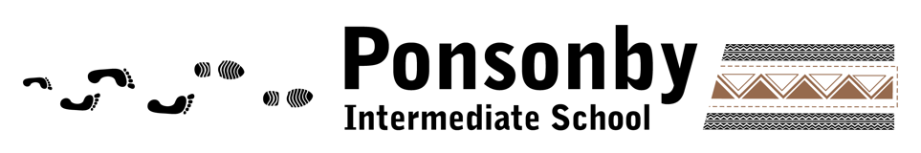

Please tick if your child suffers from any of the following:

☐ Heart Condition ☐ Dizzy Spells ☐ Sleep Walking ☐ Migraines ☐ Travel Sickness
☐ Asthma ☐ Blackouts ☐ Seizures

Any other please specify: ______________________________________________________

Any allergies to:

☐ Penicillin ☐ Foods ☐ Medication ☐ Insects

Any other please specify: ______________________________________________________

Dietary Information
Is your child a vegetarian or vegan? YES / NO

Please specify any special dietary needs: ____________________________________________________________________________________________________________

Water Safety Information
Do you give permission for your child to participate in water activities YES / NO
(e.g., kayaking, water slides or raft building)

Please specify where you think your child’s swimming ability is currently at:
(1 = Not confident 5 = Very strong and capable swimmer)

1 2 3 4 5

If there is any additional information you would like to provide the school, please use the space below:
________________________________________________________________________________________________________________________________________________________________________________________________________________________

I understand that is the responsibility of the parent and/or caregiver to disclose any medical information as requested by the school to ensure that Ponsonby staff are aware of any medical issues when participating in an EOTC or sports event.

